Lesson 03 Demo 02

Creating a Blob Storage

Objective: To configure a blob and store it in a storage account

Tools Required: Azure account

Prerequisites: None

Steps to be followed:
- Create a blob storage
- Upload a block blob
- Download a block blob

Step 1: Create a blob storage

- Navigate to the new Storage accounts in the Azure portal

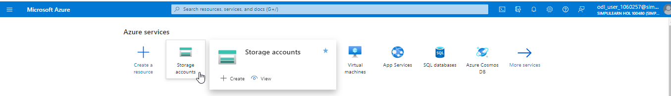

- Click on + Create, fill in the Basics tab, click on Review, and then select Create

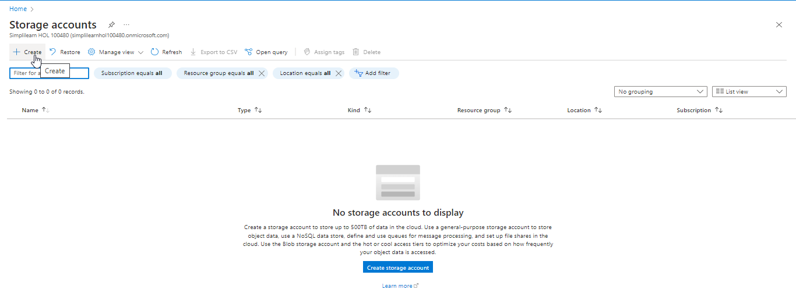

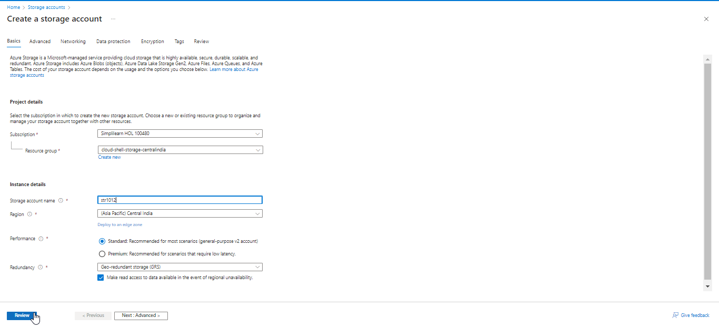

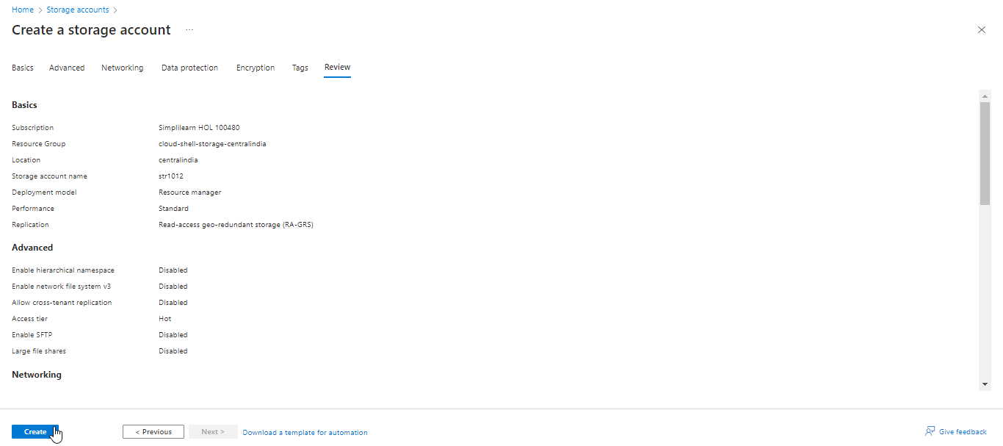

The storage account output will appear as follows:

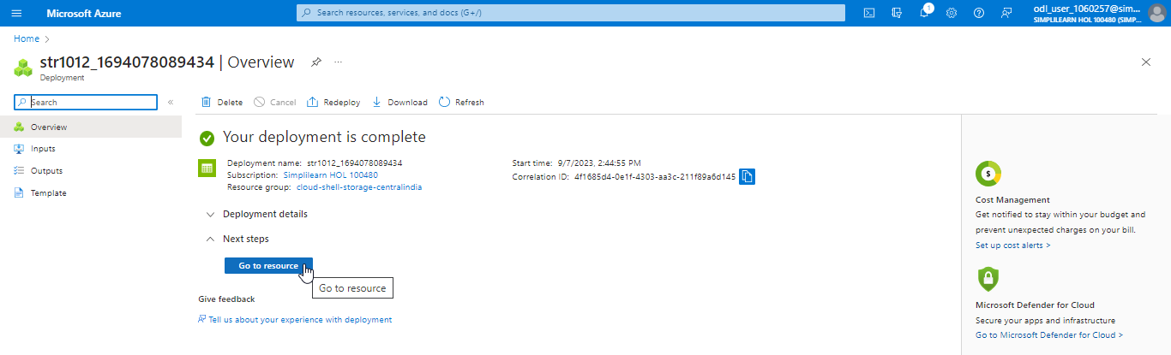

Step 2: Upload a block blob

- Navigate to the storage that was created by the user by clicking on Go to resource



  - Select the storage to show a list of blobs it contains. Since this storage is new, it does not have any blobs.

  - Select the Upload button to upload a blob to the storage and then click on Create new

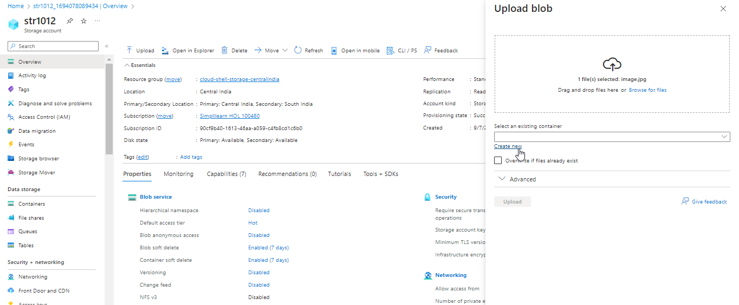

  - Fill in the details in the New container tab and click on Ok

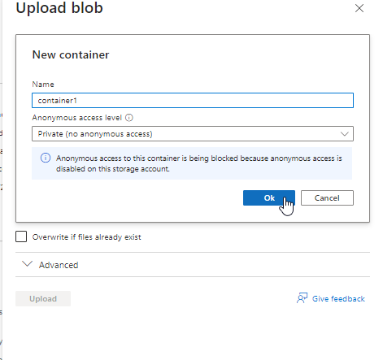

  - Expand the Advanced section. Check the Blob type and Access tier based on the storage requirement.

Note:
For general-purpose usage, the Block type would be Block Blob and Access tier as Hot (Inferred).
Click on the Upload button to upload the blob

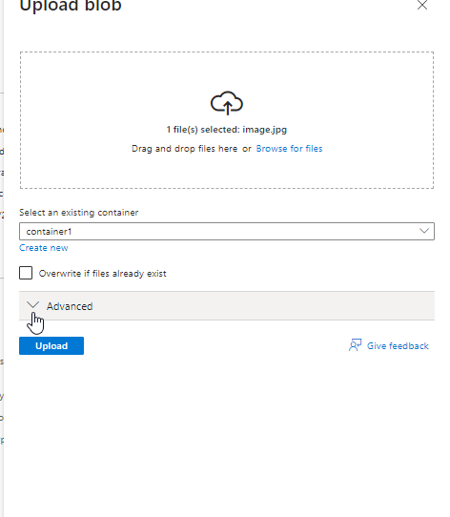

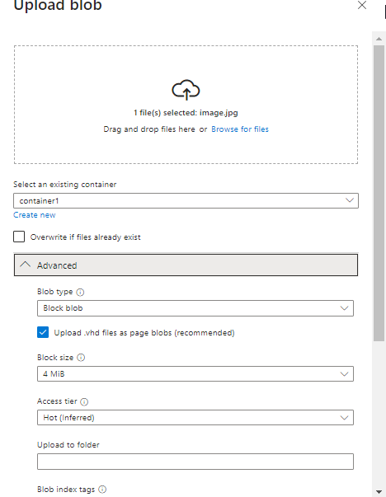

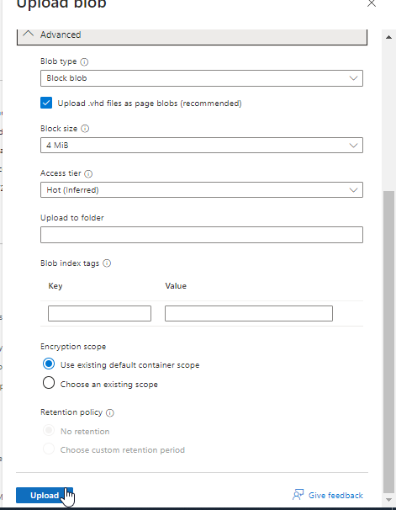

Step 3: Download a block blob

- Navigate to the created storage account

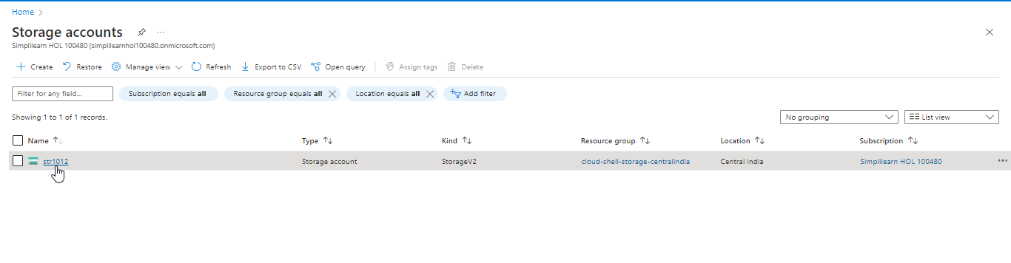

3.2 Click on Containers and then select container 1
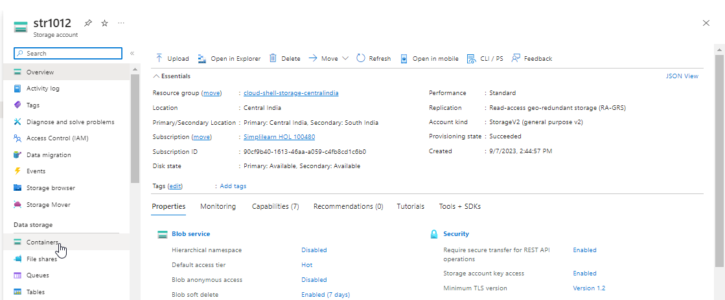
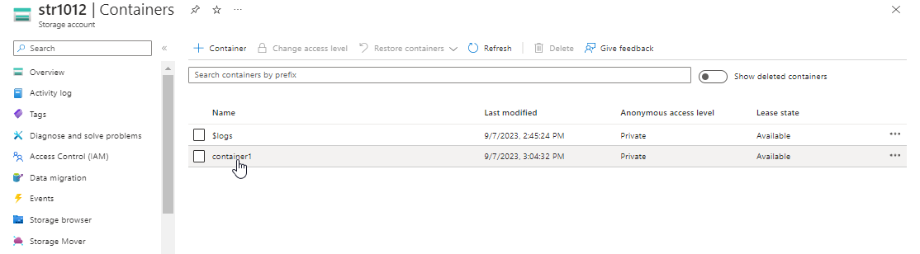

  - Right-click the blob that the user wants to download and click on Download

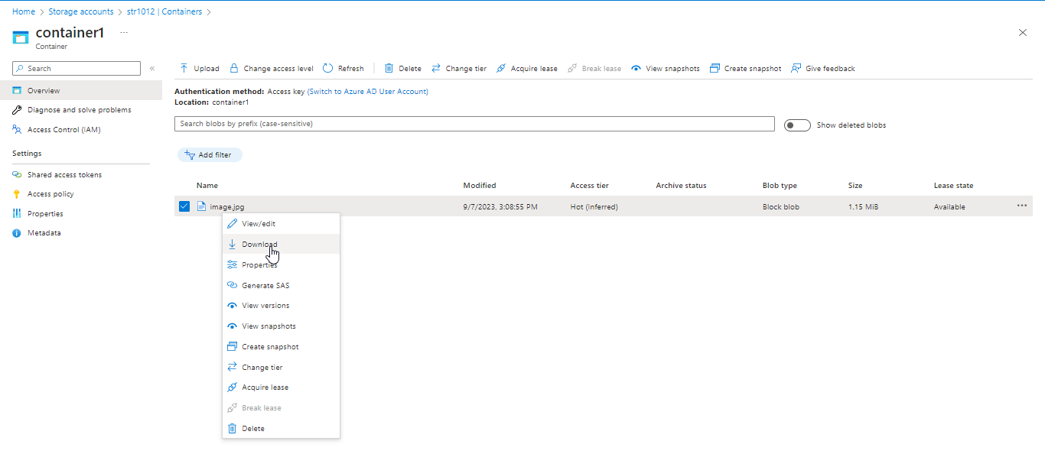

You have now successfully created the blob inside a storage account to host the unstructured data in Azure.

